Lab – Determine the MAC Address of a Host

1. Topology



1. Addressing Table

|  |  |  |  |
| --- | --- | --- | --- |
| Device | Interface | IP Address | Subnet Mask |
| PC | VLAN 1 | 192.168.1.2 | 255.255.255.0 |

1. Objectives

* Determine the MAC address of a Windows computer on an Ethernet network using the **ipconfig /all** command.
* Analyze a MAC address to determine the manufacturer.

1. Background / Scenario

Every computer on an Ethernet local network has a Media Access Control (MAC) address that is burned into the Network Interface Card (NIC). Computer MAC addresses are usually displayed as 6 sets of two hexadecimal numbers separated by dashes or colons (example: 15-EF-A3-45-9B-57). The **ipconfig /all** command displays the computer MAC address. You may work individually or in teams.

1. Required Resources

* PC running Windows 10 with at least one Ethernet network interface card (NIC)
* Connectivity to the Internet

1. Locating the MAC Address on a Computer

In this part of the lab, you will determine the MAC address of a computer using the Windows **ipconfig** command.

* + 1. Open a Windows command prompt window

Right-click on the **Start** button and select **Command Prompt**.

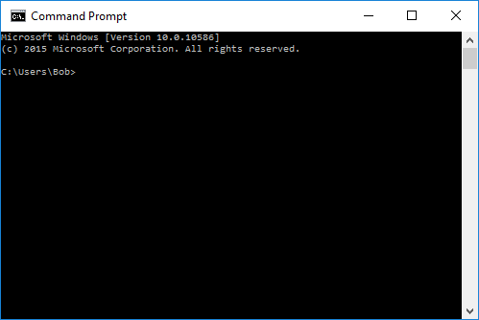

* + 1. Use the *ipconfig /all* command

Enter the **ipconfig /all** command at the command prompt. Press Enter. (Typical results are shown in the following figure, but your computer will display different information.)

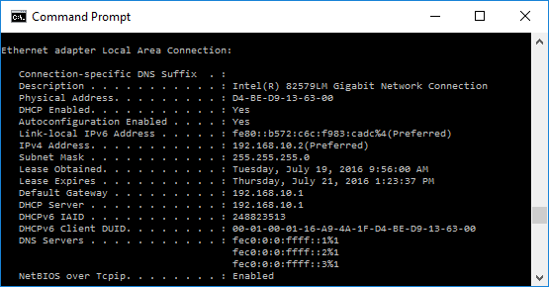

* + 1. Locate the MAC (physical) address(es) in the output from the *ipconfig /all* command

Use the table below to fill in the description of the Ethernet adapter and the Physical (MAC) Address:

|  |  |
| --- | --- |
| Description | Physical Address |
| Ethernet adapter Ethernet | E4-E7-49-BB-24-8F |
| Wireless LAN adapter Local Area connection* 1 | 0E-96-E6-54-9D-61 |
| Wireless LAN adapter Local Area Connection* 2 | 8E-96-E6-54-9D-61 |
| Ethernet adapter VMware Network Adapter VMnet1 | 00-50-56-C0-00-01 |
| Ethernet adapter VMware Network Adapter VMnet8 | 00-50-56-C0-00-08 |
| Wireless LAN adapter Wi-Fi | 0C-96-E6-54-9D-61 |

How many MAC addresses did you discover in your PC? 6

1. Analyzing the Parts of a MAC Address

Every Ethernet network interface has a physical address assigned to it when it is manufactured. These addresses are 48 bit (6 bytes) long and are written in hexadecimal notation. MAC addresses are made up of two parts. One part of the MAC address, the first 3 bytes, represents the vendor who manufactured the network interface. This part of the MAC is called the OUI (Organizationally Unique Identifier). Each vendor who wants to make and sell Ethernet network interfaces must register with the IEEE in order to be assigned an OUI.

The second part of the address, the remaining 3 bytes are the unique ID for the interface. All MAC addresses that begin with the same OUI must have unique values in the last 3 bytes.

In the example shown in the lab, the physical MAC address for the Ethernet LAN interface is D4-BE-D9-13-63-00.

|  |  |  |
| --- | --- | --- |
| Manufacturer OUI | Unique Identifier for the Interface | Vendor Name |
| D4-BE-D9 | 13-63-00 | Dell Incorporated |

* + 1. List MAC addresses discovered by you and your classmates in Part 1, Step 3a.

List the 3-byte Manufacturer OUI and the 3-byte unique interface identifier. You will fill in the Vendor name in Step 2.

|  |  |  |
| --- | --- | --- |
| Manufacturer OUI | Unique Identifier for the Interface | Vendor Name |
| D4-BE-D9 | 13-63-00 | Dell Incorporated |
| E4-E7-49 | BB-24-8F | Hewlett Packard |
| 0E-96-E6 | 54-9D-61 | (No) |
| 8E-96-E6 | 54-9D-61 | (No) |
| 00-50-56 | C0-00-01 | VMware, Inc. |
| 00-50-56 | C0-00-08 | VMware, Inc. |
| 0C-96-E6 | 54-9D-61 | Cloud Network Technology (Samoa) Limited |

* + 1. Lookup the vendors who are the registered owners of the OUI that you listed in the table.
       1. Wireshark.org provides an easy to use lookup tool at <https://www.wireshark.org/tools/oui-lookup.html>. Use this tool, or use the Internet to search for other ways to identify an OUI.

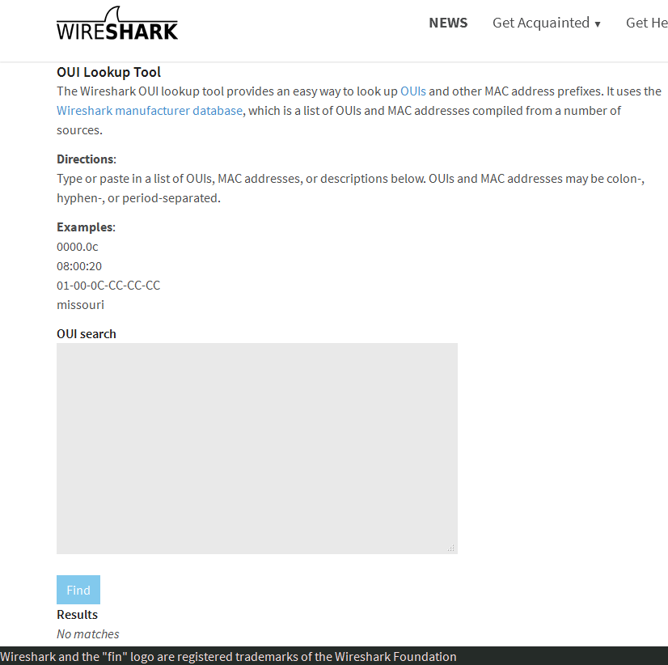

* + - 1. Use the information that you found to update the vendor column in the chart in Step 1a. How many different vendors did you discover? 3

1. Reflection
   1. Why might a computer have more than one MAC address?

A computer might have more than one MAC address in order to be able to connect to more kinds of networks available.

* 1. The sample output from the **ipconfig /all** command shown previously had only one MAC address. Suppose the output was from a computer that also had wireless Ethernet capability. How might the output change?

_______________________________________________________________________________________

_______________________________________________________________________________________

_______________________________________________________________________________________

* 1. Try connecting and disconnecting the network cable(s) to your network adapter(s) and use the **ipconfig /all** again. What changes do you see? Does the MAC address still display? Will the MAC address ever change?

_______________________________________________________________________________________

_______________________________________________________________________________________

_______________________________________________________________________________________

* 1. What are other names for the MAC address?

Physical address